
Copy School
Crest into a text box here before printing or simply delete this text box

(School Name Here)
Anti-Bullying Campaign
Name: _____________

Class: ______________

Date: ______________

WRITE IN THE CLOUDS WHAT YOU THINK THE CHILDREN ARE THINKING

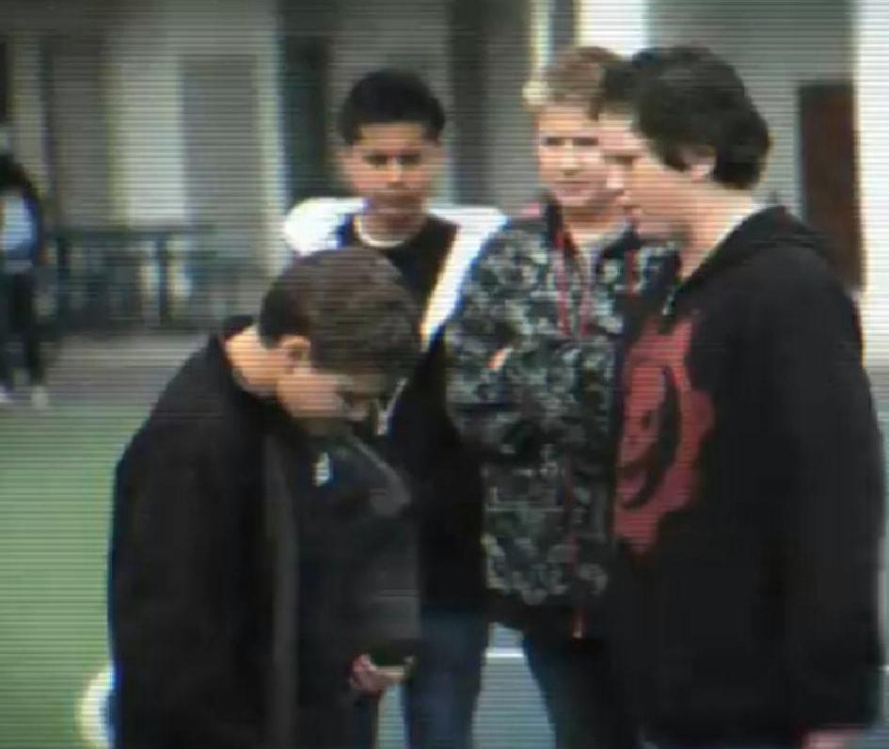


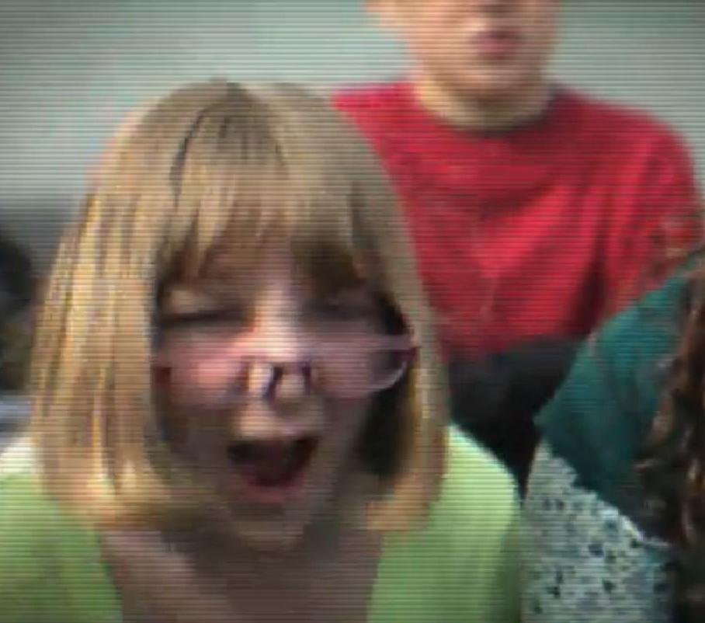

They are always picking on me

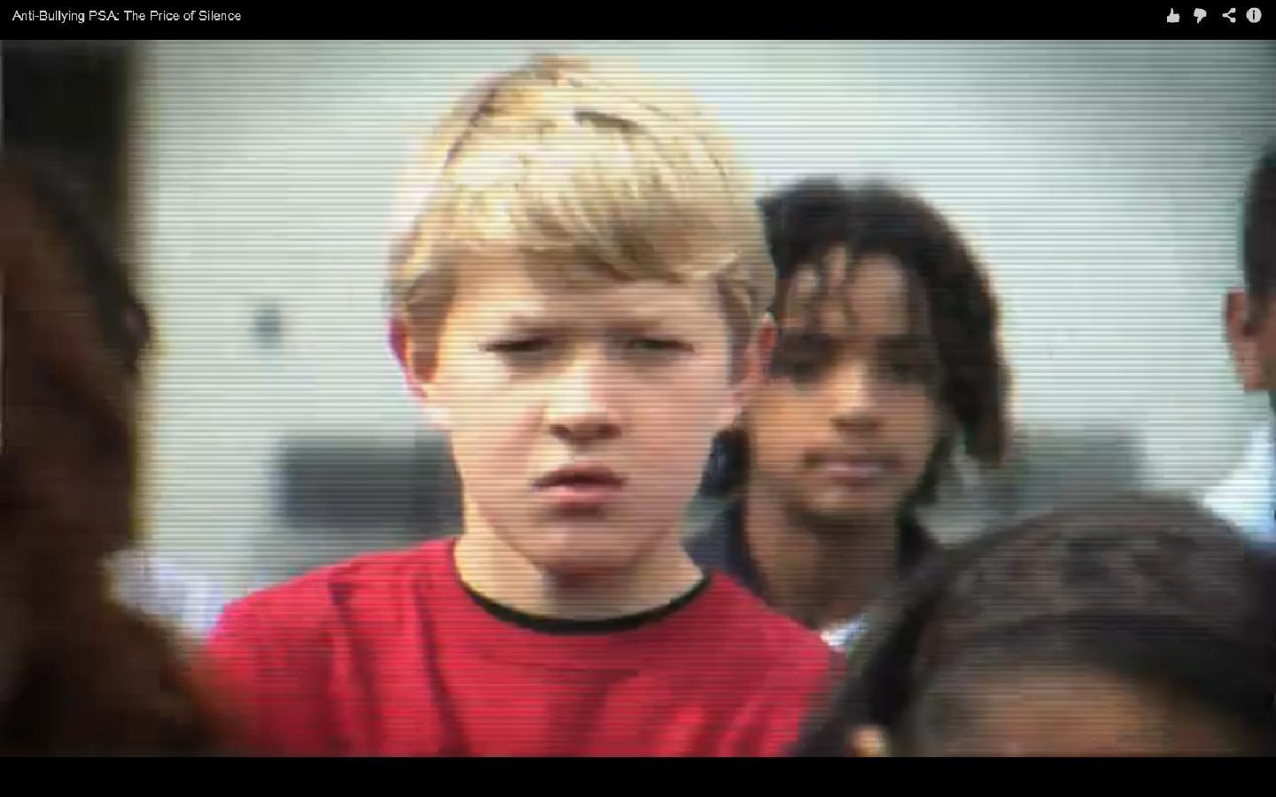

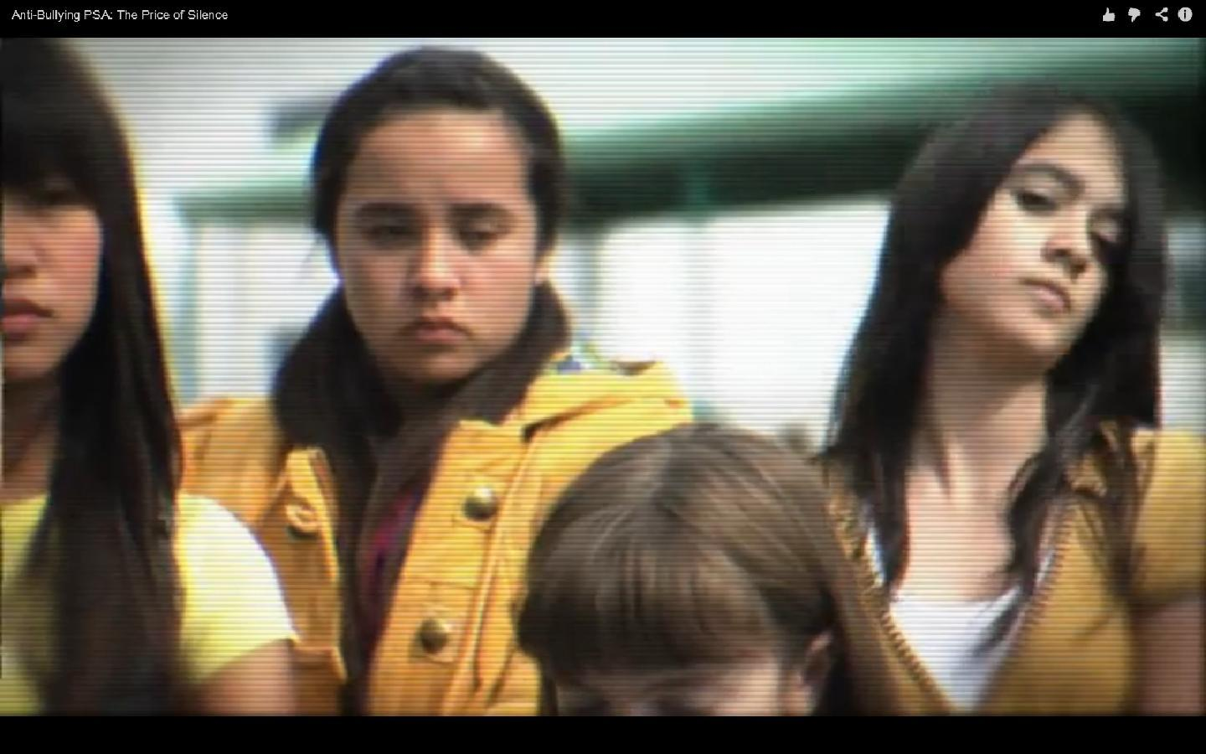

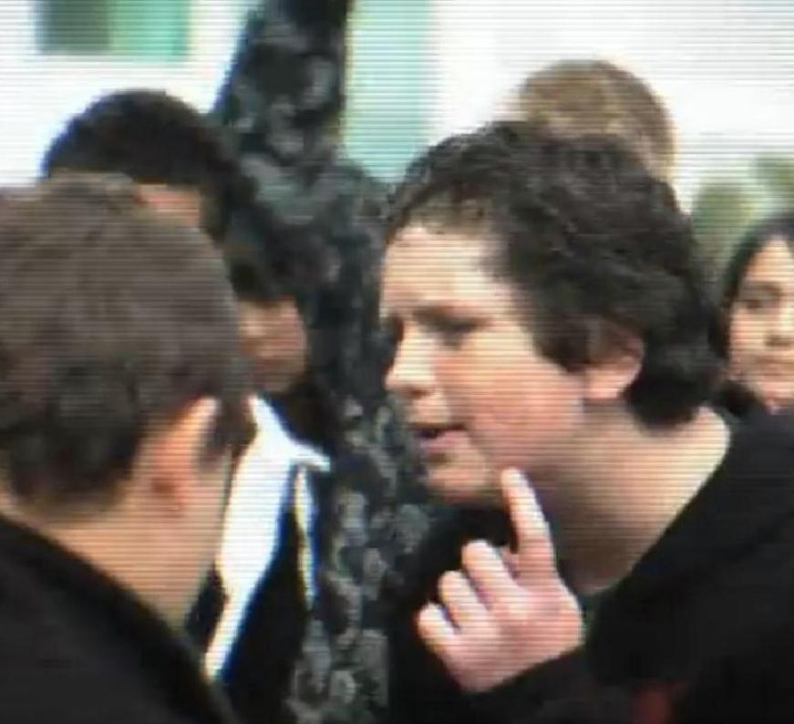

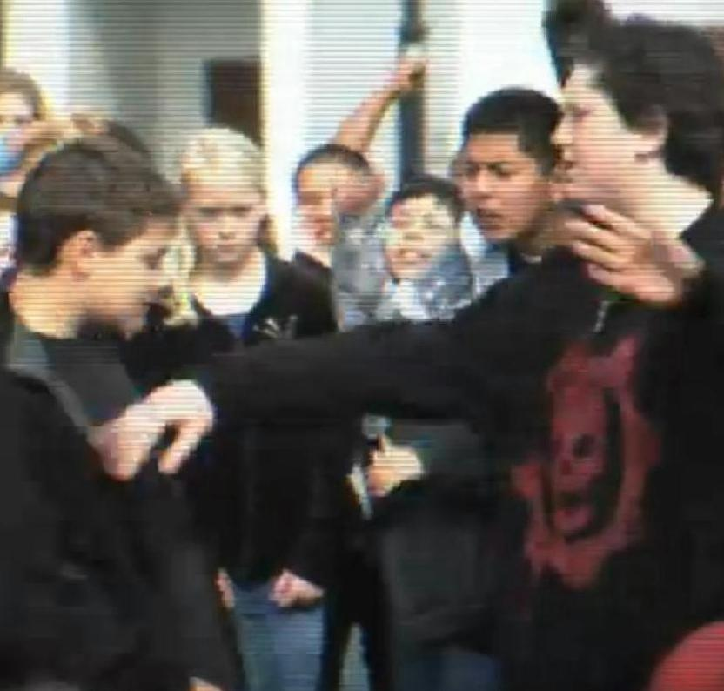

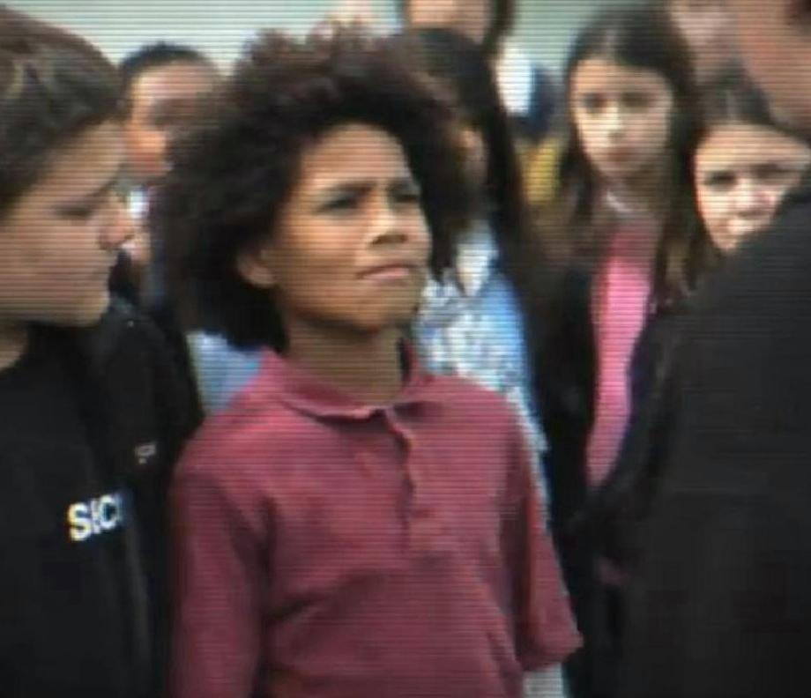

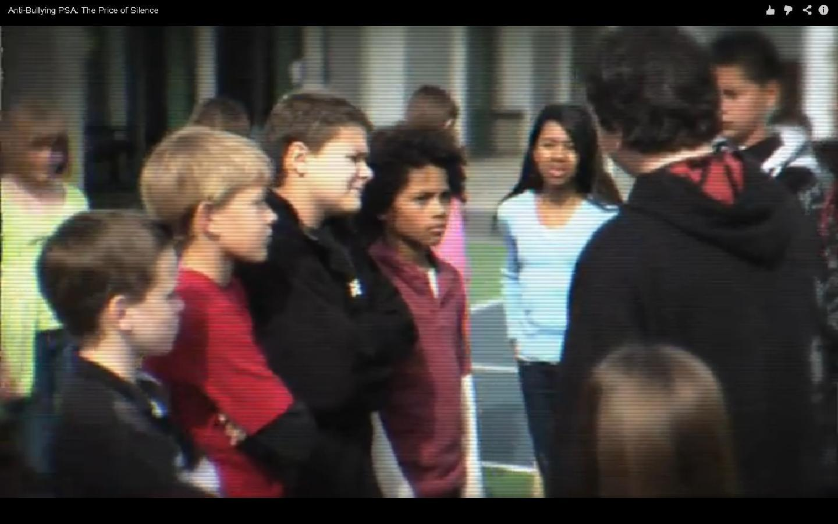

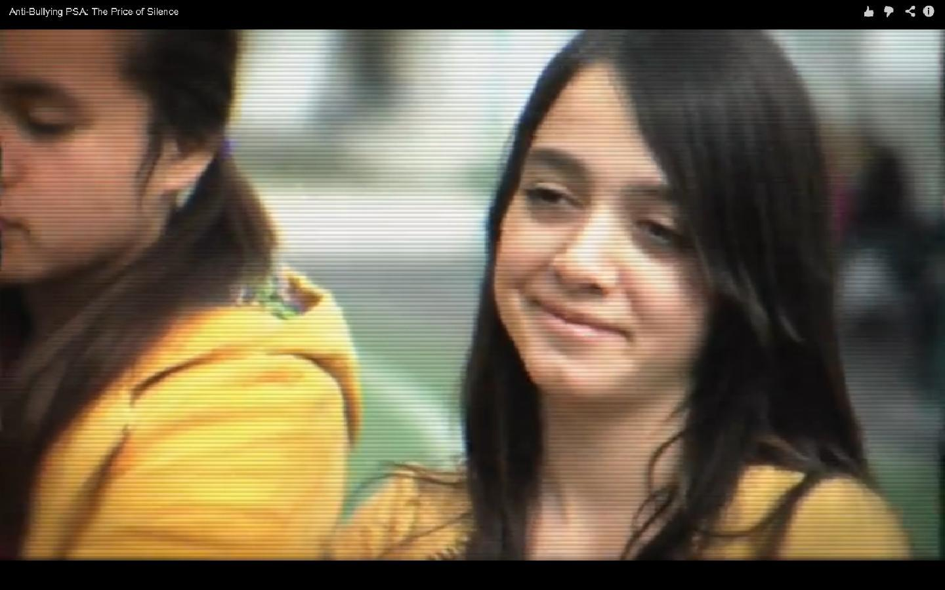

"The world is a dangerous place, not because of those who do evil, but because of those who look on and do nothing." Albert Einstein.

